Fondant Preparation Steps and Recipe

- Assemble Equipment in Advance
  - Measuring Cups [4 or 8 cup]
  - Immersion blender [see picture] or a sturdy hand whisk will work too
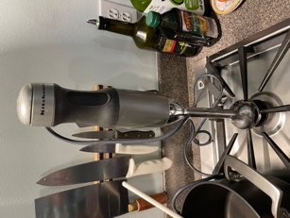
  - Strong spoon
  - Pot [size depends on 8 or 16 cups of sugar]
  - Digital thermometer with pan hook
  - Measuring spoons for vinegar
  - Water
  - Sugar
  - Vinegar
  - Additives [e.g. HiveAlive, HoneyBee Healthy, none]
  - Parchment or wax paper
  - Paper or flat plates
- Recipe Is 4:1 sugar:water
  - 4-pound bag of sugar is about 16 cups sugar
  - Mix 4-pound bag with 4 cups water for 4 generous fondant patties
  - Scales up easily; two 4-pound bags and 4 cups water for 8 generous patties
- Measure sugar and water 4:1 and put in pan
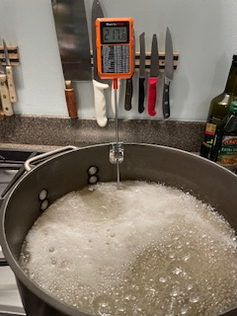
  - Stir to dissolve
  - Place on burner and turn on med-high
- Hang thermometer on pot and heat without stirring [this will boil and be very hot]
  - Syrup will turn from cloudy to clear as it heats toward 234.5 degrees, close to 234 degrees the contents will turn to clear bubbling liquid
  - Heat to exactly 234.5 and remove from heat and place in sink or cool stove burner to cool

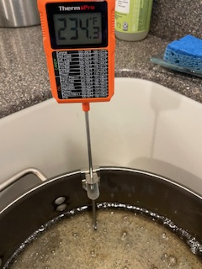

- When done heating cool the pot either in a water bath of cold water if you have the room or let cool on the stove – BUT no water should splash into the pot while cooling!
- Let cool without stirring until 190 degrees
  - Add ¼ teaspoon vinegar per 8 cups of sugar 4:1 [1/2 tsp for 4-pound bag]
  - Let syrup continue to cool without stirring
- At 135 degrees add any additives without stirring [Hive Alive, HoneyBHealthy or nothing]

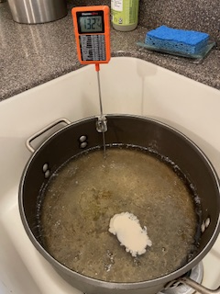

- When syrup reaches 130 degrees use immersion blender [or strong hand whisk] to stir in vinegar and additives
  - Use blender [or whisk] in an up and down mode to introduce air – mixture will turn from clear to white very quickly [less than 2 minutes]
  - It should take about two minutes for mixture to turn completely white and form firm peaks

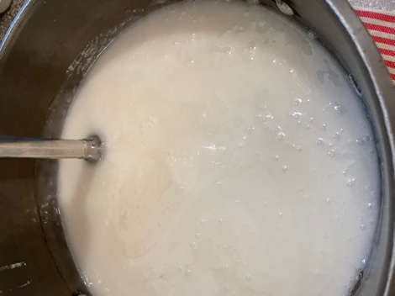

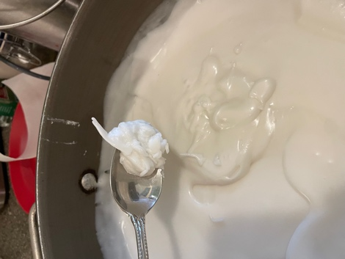

- Immediately transfer fondant using strong spoon to parchment or waxed paper squares on a paper plate
  - Mixture should be in a mounded pile on paper plates
  - Take another piece of paper to gently push and form the smooth thin fondant patty
  - Make sure top and bottom of patty is covered with paper to prevent sticking in stacking process
  - Taste it you like – it is good

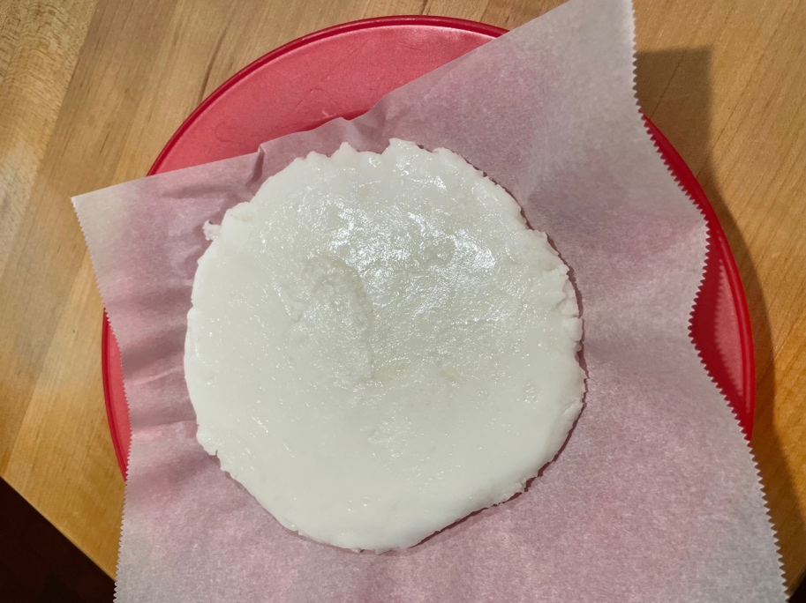
- Store in Ziplock bags in freezer and thaw before using

